Project On
Library Management System

Debayan Sutradhar
Class 10, Section B
South City International School
2019-2020
Acknowledgments

I would like to thank the creator of StackOverflow and Tutorialspoint for their wonderful articles, and of course, my computer teacher, Mr. Abhishek, to help me understand the basics of the Java programming knowledge. I would also like to thank my parents for providing me the necessary requirements to complete this project on time.

Index

Sl. No | Name | Page No.
1 | Title Of The Project
2 | Objective Of The Project
3 | Project Category
4 | Hardware used
5 | Software used
6 | User/Operational Manual
7 | Source Code
8 | Output
9 | Database Used
10 | Bibliography

Title Of The Project

Library Management System

Objective Of The Project

The Objective Of The Project is to create a Character based, non-graphic Library Management System which can be used to issue books, return books, and to manage an organized system of library users.

Project Category

This is a character based, Core Java 12 project. This project does NOT use any type of external library that is not included in the standard JDK12 distribution. Instead of a Database backend like Microsoft Access, this project is solely based on reading and writing files, where the data is mainly stored.

Hardware Used

Processor : AMD Ryzen 7 2700X
RAM : 16 GB DDR4 @ 2400MHz

Software Used

Operating System : Pop! OS (Based On Ubuntu)
Front End : Character User Interface, Java 12
Back End : Basic File Reading/Writing

User/Operational Manual

Since this project does not use Microsoft Access or any Database backend, and instead depends upon basic File Manipulation (Reading & Writing). The project consists of 4 classes :
- Main Class
- io Class
- book Class
- user Class
In order to run the project, the user must run the Main Class ONLY by the following command : (Provided that the command is executed in the same directory where the classes are)
java Main
Source Code:

Main Class:

import java.io.*;
import java.text.DateFormat;
import java.text.SimpleDateFormat;
import java.util.ArrayList;
import java.util.Date;
import java.util.List;

public class Main {

public static void main(String[] args) {
mainMenu(true);
}

static user currentUser;

static void mainMenu(boolean showIntro)
{
if(showIntro)
{
io.print("LIBRARY MANAGMENT SYSTEM\n" +
"By Debayan\n");
}

io.print("Select any one of the following\n" +
"1. Login\n" +
"2. Exit\n\n");

String userResponse = io.readLine();
io.println(userResponse);

if(userResponse.equals("1"))
{
showLoginPrompt();
}
else if(userResponse.equals("2"))
{
System.exit(0);
}
else
{
io.println("Incorrect Option!");
mainMenu(false);
}
}

static void showLoginPrompt()
{
io.println("Username : ");
String usernamePassed = io.readLine();
io.println("Password : ");
String passwordPassed = io.readLine();

user loginUser = new user(usernamePassed);
if(loginUser.doesExist)
{
if(loginUser.password.equals(passwordPassed))
{
io.println("Logged In!");
currentUser = loginUser;
if(loginUser.privilege == 1)
{
userMenu(true);
}
else if(loginUser.privilege == 0)
{
userMenu(true);
}
}
else
{
io.println("Incorrect Password!");
mainMenu(false);
}
}
else
{
io.println("Incorrect Username/Password");
mainMenu(false);
}
}

static void userMenu(boolean showWelcome)
{
if(showWelcome)
{
io.println("---- Welcome "+currentUser.firstName+"! ----");
}

if(currentUser.privilege == 0)
{
io.println("Menu\n" +
"1. Return a book\n" +
"2. Issue a book\n" +
"3. All books issued till date\n" +
"4. Profile Details\n" +
"5. Logout");
}
else
{
io.println("Menu\n" +
"1. Get Profile Details (by username)\n" +
"2. List all Users\n" +
"3. Delete a user (by username)\n" +
"4. Register a new user!\n" +
"5. Get Book Details (by Book ID)\n" +
"6. List All Books of the library\n" +
"7. Register a new book\n" +
"8. Delete a book (by Book ID)\n" +
"9. Logout");
}

String choice = io.readLine();

if(currentUser.privilege == 0)
{
if(choice.equals("1"))
{
while(true)
{
ArrayList<String> booksToReturnTransactionID = currentUser.booksToReturn();
if(booksToReturnTransactionID.size() == 0)
{
io.println("No books to return!");
userMenu(false);
break;
}
else
{
io.println("Books To Be Returned : ");
int i = 0;
io.println("-1. Return");
ArrayList<String> booksToReturnTIDFiltered = new ArrayList<>();
for(String eachTransactionID: booksToReturnTransactionID)
{
book eachBook = new book(currentUser.bookTransaxStatus.get(eachTransactionID)[0]);
io.println(i+". "+eachBook.name+" "+eachBook.author+" "+eachBook.id+" "+eachBook.isbn);
i++;
booksToReturnTIDFiltered.add(eachTransactionID);
}

io.println("Which one to return ?");
try
{
int userChoice = Integer.parseInt(io.readLine());
if(userChoice == -1)
{
userMenu(false);
break;
}
else
{
currentUser.returnBook(booksToReturnTIDFiltered.get(userChoice));
io.println("Returning to main menu ...");
userMenu(false);
break;
}
}
catch (Exception e)
{
io.println("Invalid Choice Entered");
}
}
}
}
else if(choice.equals("2"))
{
while(true)
{
io.println("Enter the book ID you want to issue \nEnter -1 to return");
String bookToBeIssuedIDEntered = io.readLine();
if(bookToBeIssuedIDEntered.equals("-1"))
{
userMenu(false);
}
else
{
currentUser.issueBook(bookToBeIssuedIDEntered);
}
}
}
else if(choice.equals("3"))
{
currentUser.printAllBooksInfoTillDate();
userMenu(false);
}
else if(choice.equals("4"))
{
currentUser.printProfileDetails();
userMenu(false);
}
else if(choice.equals("5"))
{
mainMenu(false);
}
else
{
io.println("Invalid Option!");
userMenu(false);
}
}
else if(currentUser.privilege == 1)
{
if(choice.equals("1"))
{
while(true)
{
io.println("Enter profile username\nEnter -1 to return\n");
String usernameEntered = io.readLine();
if(usernameEntered.equals("-1"))
{
userMenu(false);
break;
}
else
{
user requiredUser = new user(usernameEntered);
if(requiredUser.doesExist)
{
requiredUser.printProfileDetails();
if(requiredUser.privilege == 0)
{
requiredUser.printAllBooksInfoTillDate();
}
}
else
{
io.println("Username "+usernameEntered+" doesn't Exist!");
}
}
}
}
else if(choice.equals("2"))
{
String[] usernames = new File("users/").list();
int i = 0;
for(String eachUsername : usernames)
{
user eachUser = new user(eachUsername);
if(eachUser.doesExist)
{
io.println(i+". ID : "+eachUsername+" Full Name : "+eachUser.firstName+" "+eachUser.lastName);
i++;
}
}
userMenu(false);
}
else if(choice.equals("3"))
{
while(true)
{
try
{
io.println("Enter username to delete\nEnter -1 to Return");
String usernameToBeDeleted = io.readLine();
if(usernameToBeDeleted.equals("-1"))
{
userMenu(false);
break;
}
else if(usernameToBeDeleted.equals(currentUser.username))
{
io.println("You Cannot delete yourself.");
}
else
{
io.println("Deleting user ...");
File usernameFile = new File("users/"+usernameToBeDeleted);
if(usernameFile.exists())
{
boolean result = usernameFile.delete();
if(result)
{
io.println("... Successfully removed user "+usernameToBeDeleted+"!");
}
else
{
io.println("... Unable to removed user "+usernameToBeDeleted+". Please check file permissions and Try Again!");
}
}
else
{
io.println("User "+usernameToBeDeleted+" doesn't exist!");
}
}
}
catch (Exception e)
{
io.println("ERROR OCCURRED!");
e.printStackTrace();
}
}
}
else if(choice.equals("4"))
{
while(true)
{
io.println("New User Registration Page\nEnter -1 to return");
String firstName, lastName, username, password="", privilege;

boolean quitLoop = false;
while(true)
{
io.println("First Name :");
firstName = io.readLine();
if(firstName.length() == 0)
{
io.println("Please enter a valid First Name and Try Again!");
}
else
{
if(firstName.equals("-1"))
{
quitLoop = true;
}
break;
}
}

if(quitLoop)
{
userMenu(false);
break;
}

while(true)
{
io.println("Last Name :");
lastName = io.readLine();
if(lastName.length() == 0)
{
io.println("Please enter a valid Last Name and Try Again!");
}
else
{
if(lastName.equals("-1"))
{
quitLoop = true;
}
break;
}
}

if(quitLoop)
{
userMenu(false);
break;
}

while(true)
{
io.println("Username :");
username = io.readLine();
File uFile = new File(username);
if(username.length() == 0)
{
io.println("Please enter a valid username and Try Again!");
}
else if (uFile.exists())
{
io.println("Username already taken! Please try a new username!");
}
else
{
if(username.equals("-1"))
{
quitLoop = true;
}
break;
}
}

if(quitLoop)
{
userMenu(false);
break;
}

while(true)
{
io.println("Password :");
String pass1 = io.readLine();
if(pass1.equals("-1"))
{
quitLoop = true;
break;
}
if(pass1.length() < 8)
{
io.println("Please enter a valid Password (Must Contain at least 8 letters) and Try Again!");
}
else
{
io.println("Confirm Password : ");
String pass2 = io.readLine();
if(pass1.equals(pass2))
{
password = pass2;
break;
}
else
{
if(pass2.equals("-1"))
{
quitLoop = true;
break;
}
io.println("Two passwords dont match with either. Please Try Again!");
}
}
}

if(quitLoop)
{
userMenu(false);
break;
}

while(true)
{
io.println("Privilege\n'0' : Normal User with Non-Admin rights\n'1' : Administrator Account\n");
privilege = io.readLine();
if(privilege.equals("-1"))
{
quitLoop = true;
break;
}
if(!privilege.equals("0") && !privilege.equals("1"))
{
io.println("Enter a valid privilege (0/1)");
}
else
{
break;
}
}

if(quitLoop)
{
userMenu(false);
break;
}

try
{
io.println("New user profile details:\n" +
"First Name : "+firstName+"\n" +
"Last Name : "+lastName+"\n" +
"Username : "+username+"\n" +
"Privilege : "+privilege+"\n\n" +
"Register user [Y/N] ?");

String createUserQuestionChoice = io.readLine();
if(createUserQuestionChoice.toUpperCase().equals("Y"))
{
Date date = new Date();
String timeStampFormat = "ddMMyyyy";
DateFormat returnTimeStamp = new SimpleDateFormat(timeStampFormat);
String formattedTimeStamp= returnTimeStamp.format(date);

File newUser = new File("users/"+username);
boolean newUserFileCreationResult = newUser.createNewFile();
if(newUserFileCreationResult)
{
FileWriter fw = new FileWriter(newUser);
fw.write(username+";"+firstName+";"+lastName+";0;"+password+";"+privilege+";"+formattedTimeStamp+";");
fw.close();

io.println("User "+username+" successfully created!");
}
else
{
io.println("Unable to create new file for new user. Check file permissions!");
}
}
}
catch (Exception e)
{
io.println("Unable to create new user. Check file permissions!");
e.printStackTrace();
}
}
}
else if(choice.equals("5"))
{
while(true)
{
io.println("Enter the book ID, Enter -1 to return : ");
String uc = io.readLine();
if(uc.equals("-1"))
{
userMenu(false);
break;
}
else
{
book requiredBook = new book(uc);
if(requiredBook.doesExist)
{
io.println("\n\n\n----BOOK DETAILS----" +
"\nID : "+requiredBook.id+
"\nName : "+requiredBook.name+
"\nIs available : "+requiredBook.isBookAvaialable+
"\nCurrently Issued By (null if not taken) : "+requiredBook.bookTakenBy+
"\nPrice : "+requiredBook.price+
"\nPublisher : "+requiredBook.publisher+
"\nISBN : "+requiredBook.isbn+"\n\n\n");
}
else
{
io.println("Book ID "+uc+" does not exist!");
}
}
}
}
else if(choice.equals("6"))
{
String[] bookFiles = new File("books/").list();
io.println("---All books currently present in the library---");
int i = 1;
for(String eachBookFile : bookFiles)
{
book eachBook = new book(eachBookFile);
io.println(i+". ID : "+eachBook.id+
"\nName : "+eachBook.name+
"\nIs available : "+eachBook.isBookAvaialable+
"\nCurrently Issued By (null if not taken) : "+eachBook.bookTakenBy+
"\nPrice : "+eachBook.price+
"\nPublisher : "+eachBook.publisher+
"\nISBN : "+eachBook.isbn+"\n\n");
i++;
}
userMenu(false);
}
else if(choice.equals("7"))
{
while(true)
{
io.println("New Book Registration Page\nEnter -1 to return");
String bookID, name, author, publisher, price, isbn;

boolean quitLoop = false;

while(true)
{
io.println("BOOK ID :");
bookID = io.readLine();
book thisBook = new book(bookID);
if(bookID.length() == 0)
{
io.println("Please enter a ID and Try Again!");
}
else if (thisBook.doesExist)
{
io.println("A book with the same book ID already taken! Please try a new ID!");
}
else
{
if(bookID.equals("-1"))
{
quitLoop = true;
}
break;
}
}

if(quitLoop)
{
userMenu(false);
break;
}

while(true)
{
io.println("Book Name :");
name = io.readLine();
if(name.length() == 0)
{
io.println("Please enter a valid Book Name and Try Again!");
}
else
{
if(name.equals("-1"))
{
quitLoop = true;
}
break;
}
}

if(quitLoop)
{
userMenu(false);
break;
}

while(true)
{
io.println("Publisher :");
publisher = io.readLine();
if(publisher.length() == 0)
{
io.println("Please enter a valid Publisher and Try Again!");
}
else
{
if(publisher.equals("-1"))
{
quitLoop = true;
}
break;
}
}

if(quitLoop)
{
userMenu(false);
break;
}

while(true)
{
io.println("Author Full Name :");
author = io.readLine();
if(author.length() == 0)
{
io.println("Please enter a valid Author Name and Try Again!");
}
else
{
if(author.equals("-1"))
{
quitLoop = true;
}
break;
}
}

if(quitLoop)
{
userMenu(false);
break;
}

while(true)
{
io.println("Price :");
price = io.readLine();
if(price.length() == 0)
{
io.println("Please enter a valid price and Try Again!");
}
else
{
if(price.equals("-1"))
{
quitLoop = true;
}
break;
}
}

if(quitLoop)
{
userMenu(false);
break;
}

while(true)
{
io.println("ISBN :");
isbn = io.readLine();
if(isbn.length() == 0)
{
io.println("Please enter a valid ISBN and Try Again!");
}
else
{
if(isbn.equals("-1"))
{
quitLoop = true;
}
break;
}
}

if(quitLoop)
{
userMenu(false);
break;
}

try
{
io.println("New book details:\n" +
"ID : "+bookID+"\n" +
"Name : "+name+"\n" +
"Author : "+author+"\n" +
"Publisher : "+publisher+"\n" +
"Price : "+price+"\n" +
"ISBN : "+isbn+"\n" +
"Register Book [Y/N] ?");

String createBookQuestionChoice = io.readLine();
if(createBookQuestionChoice.toUpperCase().equals("Y"))
{
File newBook = new File("books/"+bookID);
boolean newBookFileCreationResult = newBook.createNewFile();
if(newBookFileCreationResult)
{
FileWriter fw = new FileWriter(newBook);
fw.write(name+";"+author+";"+publisher+";"+price+";"+isbn+";1;null;");
fw.close();

io.println("Book "+bookID+" successfully created!");
}
else
{
io.println("Unable to create new file for new Book. Check file permissions!");
}
}
}
catch (Exception e)
{
io.println("Unable to create new Book. Check file permissions!");
e.printStackTrace();
}
}
}
else if(choice.equals("8"))
{
while(true)
{
try
{
io.println("Enter book ID to delete\nEnter -1 to Return");
String bookIDToBeDeleted = io.readLine();
if(bookIDToBeDeleted.equals("-1"))
{
userMenu(false);
break;
}
else
{
io.println("Deleting book ...");
File bookFile = new File("books/"+bookIDToBeDeleted);
if(bookFile.exists())
{
boolean result = bookFile.delete();
if(result)
{
io.println("... Successfully removed Book "+bookIDToBeDeleted+"!");
}
else
{
io.println("... Unable to removed Book "+bookIDToBeDeleted+". Please check file permissions and Try Again!");
}
}
else
{
io.println("Book "+bookIDToBeDeleted+" doesn't exist!");
}
}
}
catch (Exception e)
{
io.println("ERROR OCCURRED!");
e.printStackTrace();
}
}
}
else if(choice.equals("9"))
{
mainMenu(false);
}
else
{
io.println("Invalid Option!");
userMenu(false);
}
}
}
}

io Class:

import java.io.BufferedReader;
import java.io.InputStreamReader;

public class io {
public static BufferedReader bf = new BufferedReader(new InputStreamReader(System.in));

public static String readLine()
{
try
{
return bf.readLine();
}
catch (Exception e)
{
println("ERROR OCCURED!\nStackTrace:\n\n");
e.printStackTrace();
System.exit(0);
return null;
}
}

public static void print(String a)
{
System.out.print(a);
}

public static void println(String a)
{
System.out.println(a);
}
}

book Class:

import java.io.BufferedReader;
import java.io.File;
import java.io.FileReader;

public class book {
String id;
String name;
String author;
String publisher;
String price;
String isbn;
boolean doesExist;
boolean isBookAvaialable;
String bookTakenBy;

public book(String idPassed)
{
try
{
File bookFile = new File("books/"+idPassed);
if(bookFile.exists())
{
BufferedReader bf = new BufferedReader(new FileReader(bookFile));
String content = bf.readLine();
String part[] = content.split(";");
bf.close();

id = idPassed;
name = part[0];
author = part[1];
publisher = part[2];
price = part[3];
isbn = part[4];
bookTakenBy = part[6];

String bookAvaStatus = part[5];
if(bookAvaStatus.equals("0"))
{
isBookAvaialable = false;
}
else if(bookAvaStatus.equals("1"))
{
isBookAvaialable = true;
}

doesExist = true;
}
else
{
doesExist = false;
}
}
catch (Exception e)
{
e.printStackTrace();
doesExist = false;
}
}
}

user Class:

import java.io.*;
import java.text.DateFormat;
import java.text.SimpleDateFormat;
import java.util.ArrayList;
import java.util.Date;
import java.util.HashMap;
import java.util.List;

public class user
{
String username;
String firstName;
String lastName;
String password;
int privilege;
boolean doesExist;
String firstLine;
int booksTillDate;
String dateOfJoin;

HashMap<String,String[]> bookTransaxStatus = new HashMap<>();
ArrayList<String> booksTransactionID = new ArrayList<>();

String generateTransactionID()
{
int random = (int)(Math.random() * 32000 + 1);
return random+"";
}

public user(String fileName)
{
try
{
File userFile = new File("users/"+fileName);
if(userFile.exists())
{
BufferedReader reader = new BufferedReader(new FileReader(userFile));
firstLine = reader.readLine();

String part[] = firstLine.split(";");
username = part[0];
firstName = part[1];
lastName = part[2];
booksTillDate = Integer.parseInt(part[3]);
password = part[4];
privilege = Integer.parseInt(part[5]);
dateOfJoin = part[6];

for(int i =0;i<booksTillDate;i++)
{
String line = reader.readLine();
String part2[] = line.split(";");
String config[] = new String[4];
config[0] = part2[0];
config[1] = part2[1];
config[2] = part2[2];
config[3] = part2[3];

booksTransactionID.add(config[0]);
bookTransaxStatus.put(config[0], new String[]{config[1],config[2],config[3]});
}

reader.close();
doesExist = true;
}
else
{
doesExist = false;
}

}
catch (Exception e)
{
e.printStackTrace();
doesExist = false;
}
}

ArrayList<String> booksToReturn()
{
ArrayList<String> booksToReturn = new ArrayList<>();
for(String eachTransactionID : booksTransactionID)
{
book eachBook = new book(bookTransaxStatus.get(eachTransactionID)[0]);
String[] issueReturnDates = bookTransaxStatus.get(eachTransactionID);
if(issueReturnDates[2].equals("NOT_RETURNED"))
{
booksToReturn.add(eachTransactionID);
}
}
return booksToReturn;
}

void returnBook(String transactionID)
{
try
{
String[] bookData = bookTransaxStatus.get(transactionID);
String bookID = bookData[0];
io.println("Returning book "+bookID+"...");
Date date = new Date();
String timeStampFormat = "ddMMyyyy";
DateFormat returnTimeStamp = new SimpleDateFormat(timeStampFormat);
String formattedTimeStamp= returnTimeStamp.format(date);

String[] dates = new String[3];
dates[0] = bookID;
dates[1] = bookTransaxStatus.get(transactionID)[1];
dates[2] = formattedTimeStamp;

bookTransaxStatus.put(transactionID,dates);

reloadTransax();

io.println("Returned!");
}
catch (Exception e)
{
io.println("... Unable to Return Book!");
e.printStackTrace();
}
}

void issueBook(String bookID)
{
book bookToBeIssued = new book(bookID);
if(bookToBeIssued.doesExist)
{
boolean isAlreadyIssuedAndNotReturned = false;
for(String eachTransactionID : booksTransactionID)
{
String[] bookData = bookTransaxStatus.get(eachTransactionID);
if(bookData[0].equals(bookID) && bookData[2].equals("NOT_RETURNED"))
{
isAlreadyIssuedAndNotReturned = true;
}
}
if(isAlreadyIssuedAndNotReturned)
{
io.println("You already issued this book an didnt return it!");
}
else
{
io.println("Book Details :\n" +
"Name : "+bookToBeIssued.name+"\n" +
"Author : "+bookToBeIssued.author+"\n" +
"ISBN : "+bookToBeIssued.isbn+"\n" +
"Publisher : "+bookToBeIssued.publisher+"\n" +
"Price : "+bookToBeIssued.price+"\n\n" +
"Are you sure that you want to issue this book [Y/N]");
String userFinalIssueChoice = io.readLine();
if(userFinalIssueChoice.toUpperCase().equals("Y"))
{
try
{
io.println("Issuing book "+bookID+"...");
Date date = new Date();
String timeStampFormat = "ddMMyyyy";
DateFormat returnTimeStamp = new SimpleDateFormat(timeStampFormat);
String formattedTimeStamp= returnTimeStamp.format(date);

String newTransacID = generateTransactionID();
String[] config = new String[3];
config[0] = bookID;
config[1] = formattedTimeStamp;
config[2] = "NOT_RETURNED";
bookTransaxStatus.put(newTransacID,config);
booksTransactionID.add(newTransacID);

booksTillDate++;
reloadTransax();

io.println("...Successfully Issued!");
}
catch (Exception e)
{
io.println("... Unable to issue book! Contact admin!");
e.printStackTrace();
}
}
else
{
io.println("Cancelled.");
}
}
}
else
{
io.println("Sorry that book could not be found. Please contact Administrator for more info.");
}
}

void reloadTransax() throws Exception
{

FileWriter fw = new FileWriter("users/"+username);
fw.write(username+";"+firstName+";"+lastName+";"+booksTillDate+";"+password+";"+privilege+";"+dateOfJoin+";\n");
for(int i =0;i<booksTransactionID.size();i++)
{
String[] config = bookTransaxStatus.get(booksTransactionID.get(i));
fw.write(booksTransactionID.get(i)+";"+config[0]+";"+config[1]+";"+config[2]+";\n");
}
fw.close();
}

void printAllBooksInfoTillDate()
{
io.println("All books issued till date :-");
int i = 1;
for(String eachTransactionID : booksTransactionID)
{
String[] eachConfig = bookTransaxStatus.get(eachTransactionID);
book eachBook = new book(eachConfig[0]);
if(eachBook.doesExist)
{
io.println(i+". "+eachBook.id+" -- "+eachBook.name+" -- "+eachBook.author+" -- "+eachBook.isbn+" -- "+eachBook.price);
}
else
{
io.println(i+". "+eachBook.id+" -- Book unavailable!");
}
i++;
}
}

void printProfileDetails()
{
io.println("Profile Details :-\n" +
"Full Name : "+firstName+" "+lastName+"\n" +
"Username : "+username+"\n" +
"Account Privilege : "+privilege+"\n" +
"No. of Books Issued till date : "+booksTransactionID.size()+"\n" +
"Date Joined (DD/MM/YYYY) : "+dateOfJoin);
}
}

The Source Code can also be found on the following GitHub Repository:
https://github.com/ladiesman6969/LibraryManager
Output

Main Menu:
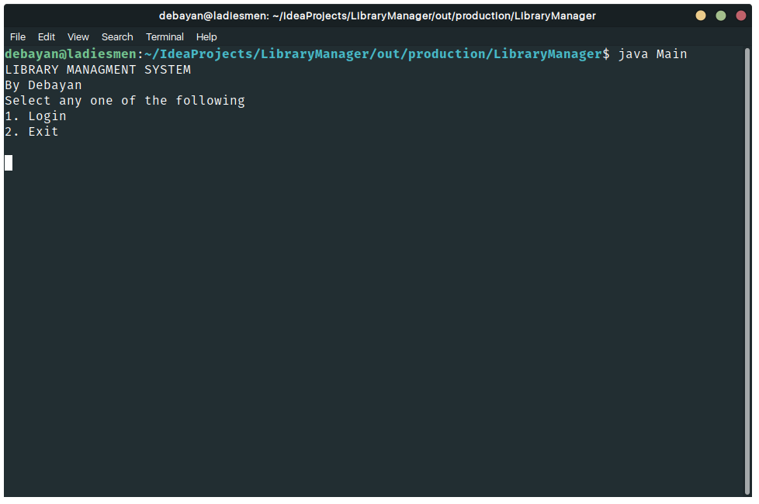
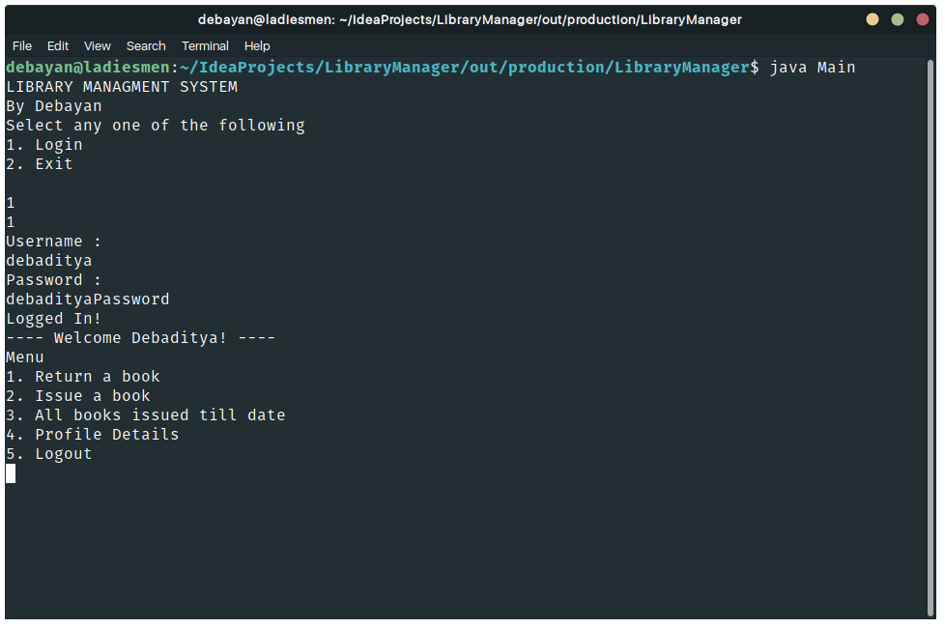
Users’ Perspective: After logging in, the user is greeted with another menu.
2. Issue a book (Issuing Test Book ‘BOOK_1’)

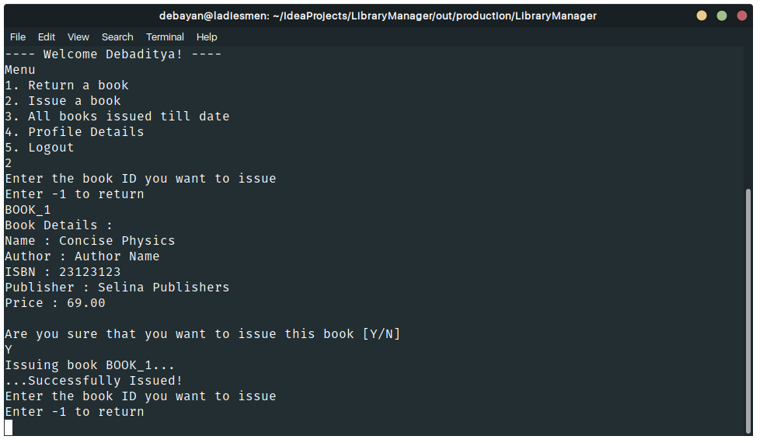
1. Return a book (Returning The Issued Book ‘BOOK_1’)

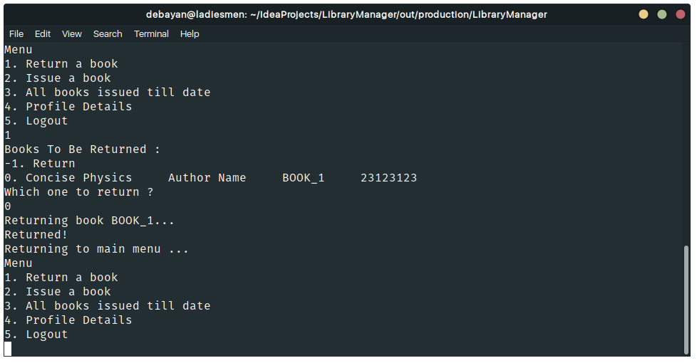

3. All books issued till date
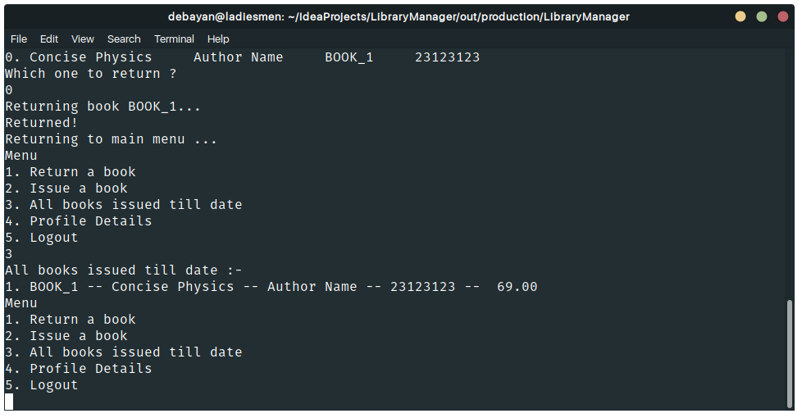
4. Profile Details
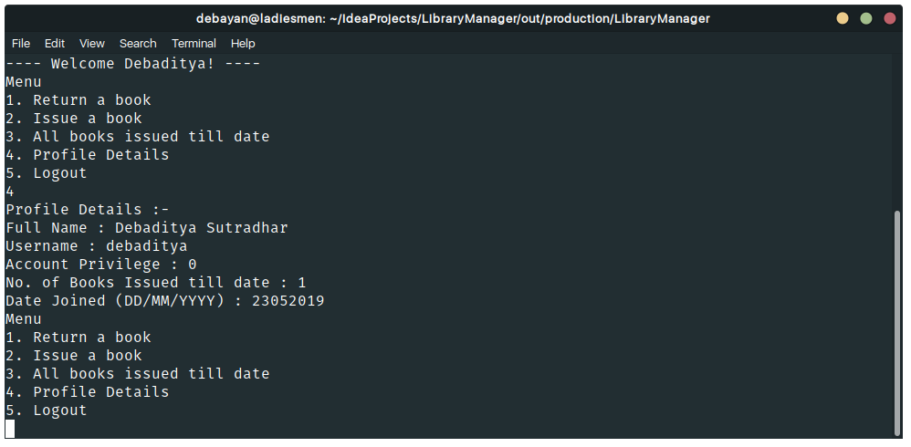

5. Logout
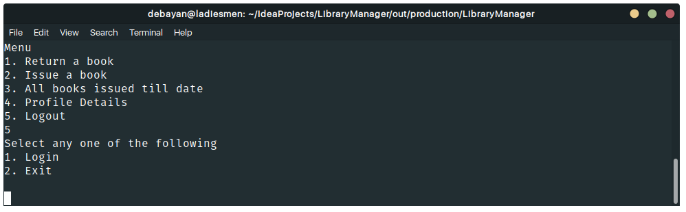

Admin’s Perspective
After login, the admin is greeted with the following menu:
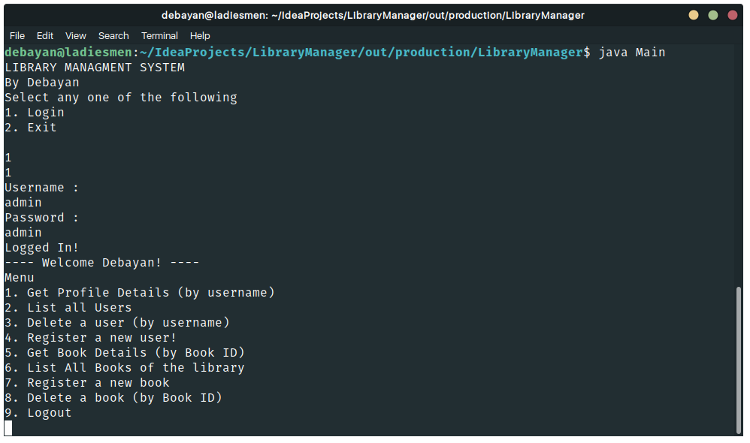

1. Get Profile Details (Input : ‘debaditya’ - a test user)
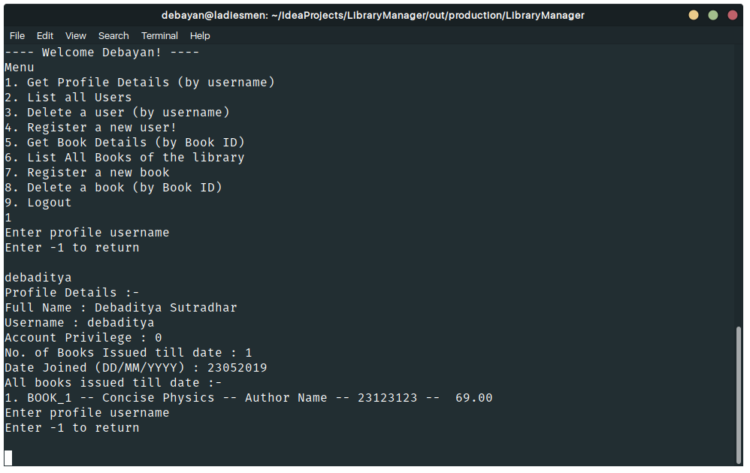
2. List all users.
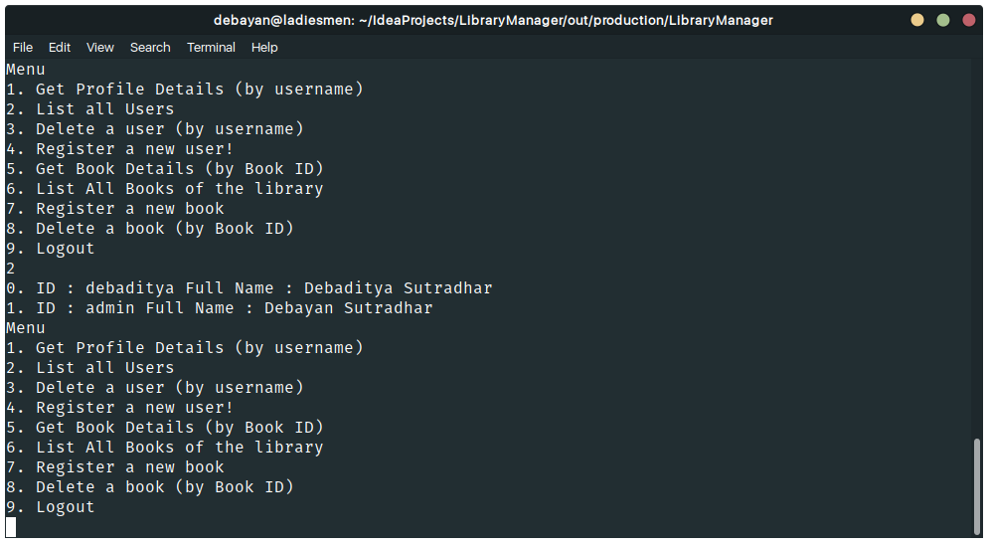
3. Delete a user (Input : ‘debaditya’ - a test user)
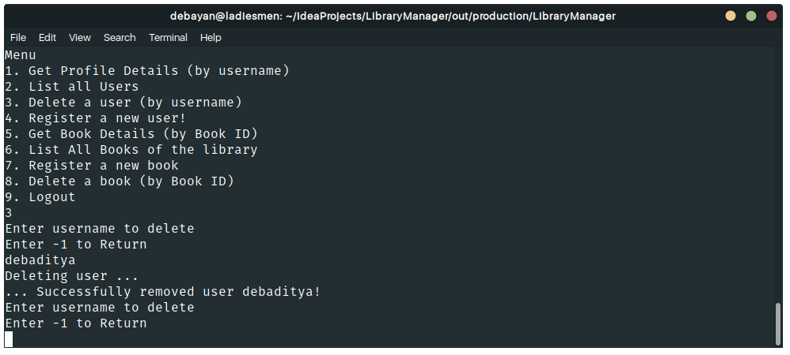
5. Get Book Details (Input : ‘BOOK_1’ - a test book)
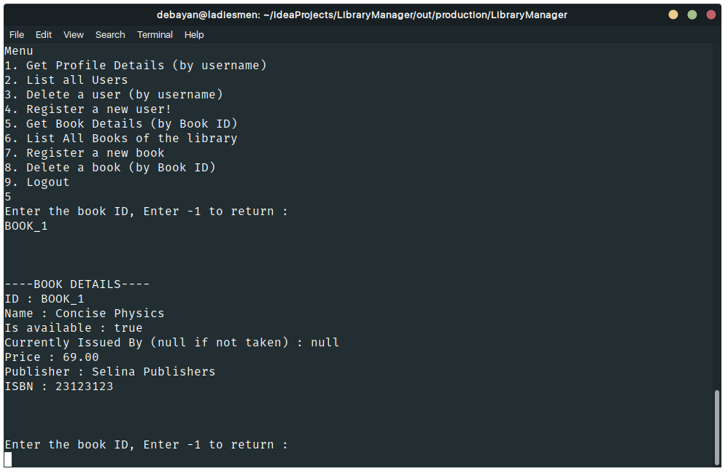

4.Register a new user. (Input : ‘user2’ - Test User)
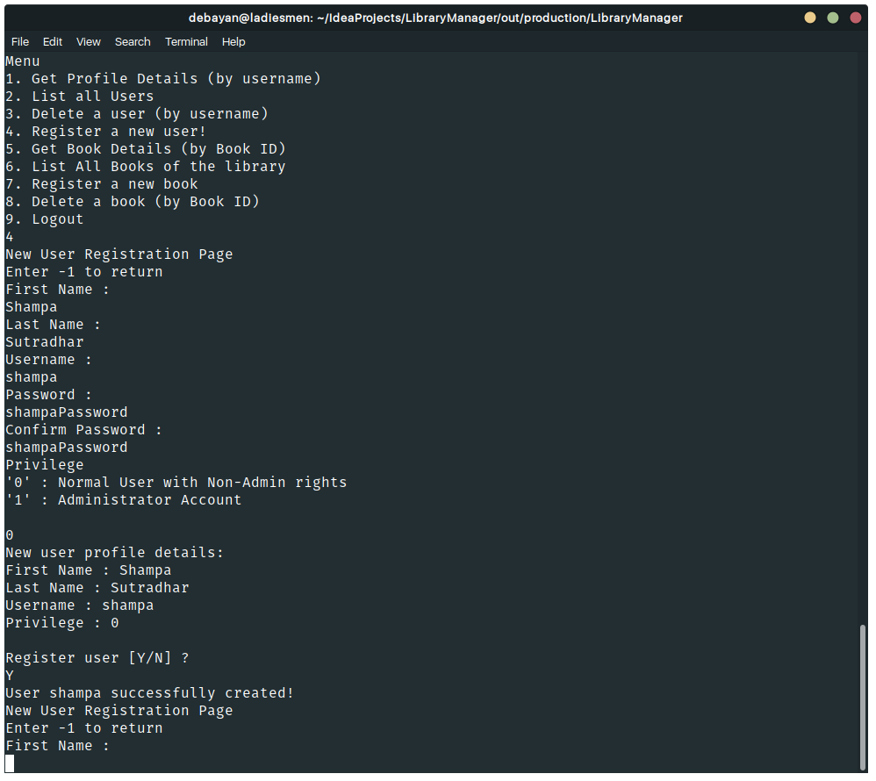

6.List All Books of the Library.
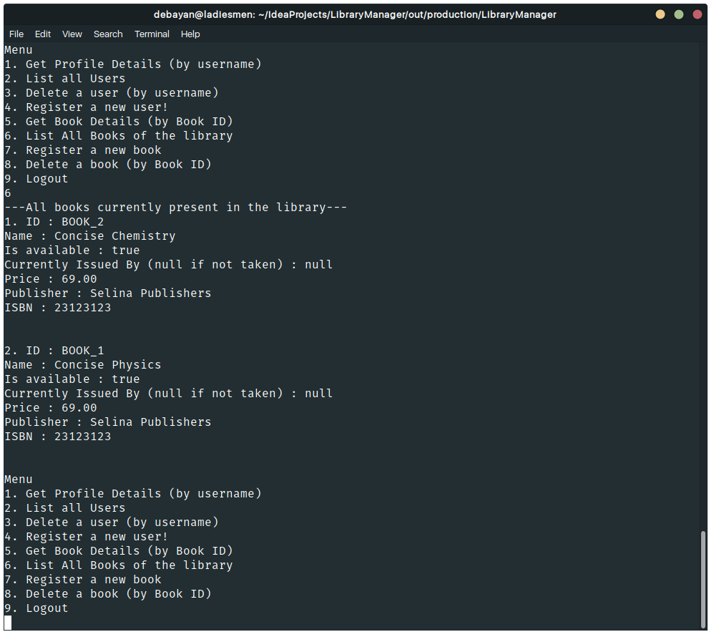
8.Delete book (Deleting Test Book ‘BOOK_1’)
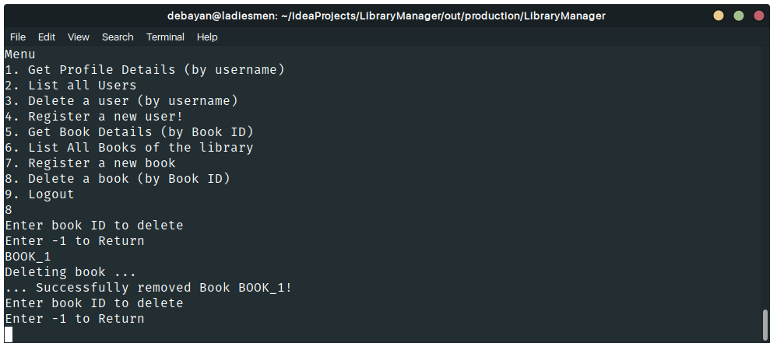

7. Register a new book (Creating ‘BOOK_3’ as new test book)
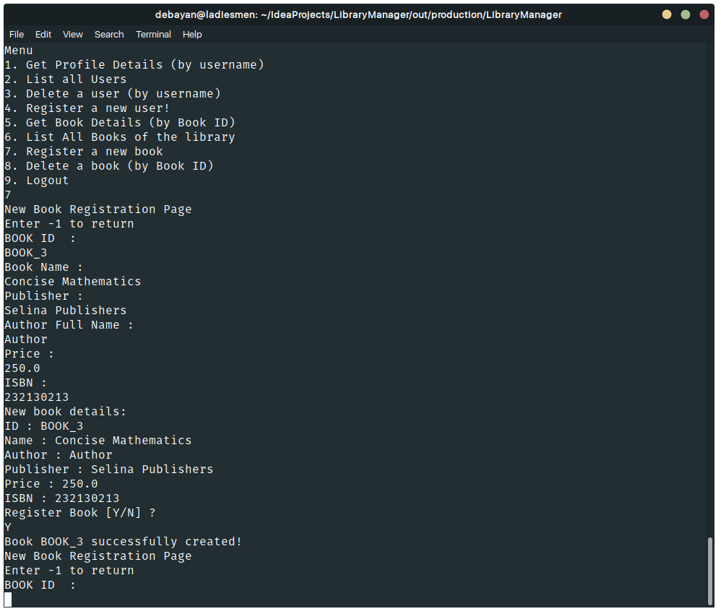
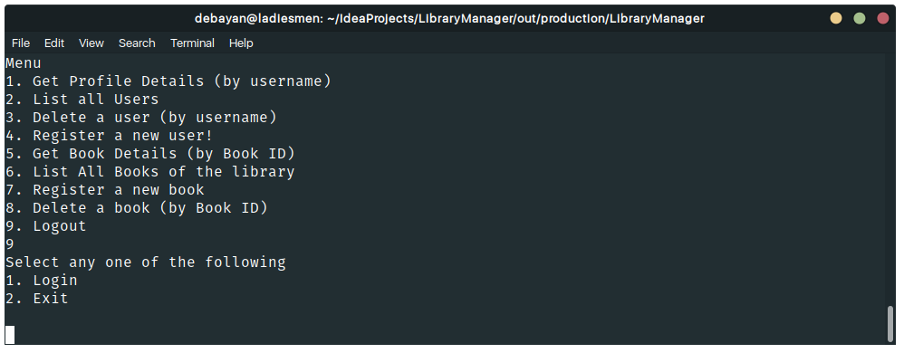
9. Logout

Database Used

As already mentioned before, this program uses NO external Database platform. The system stores data in the form of text files, which makes it faster than using a database such as Microsoft Access.

Bibliography

Jenkov Tutorials – Simple Date And Time Format
http://tutorials.jenkov.com/java-internationalization/simpledateformat.html

JavaTPoint – Java FileWriter Class
https://www.javatpoint.com/java-filewriter-class

JavaTPoint – Java BufferedReader Class
https://www.javatpoint.com/java-bufferedreader-class

